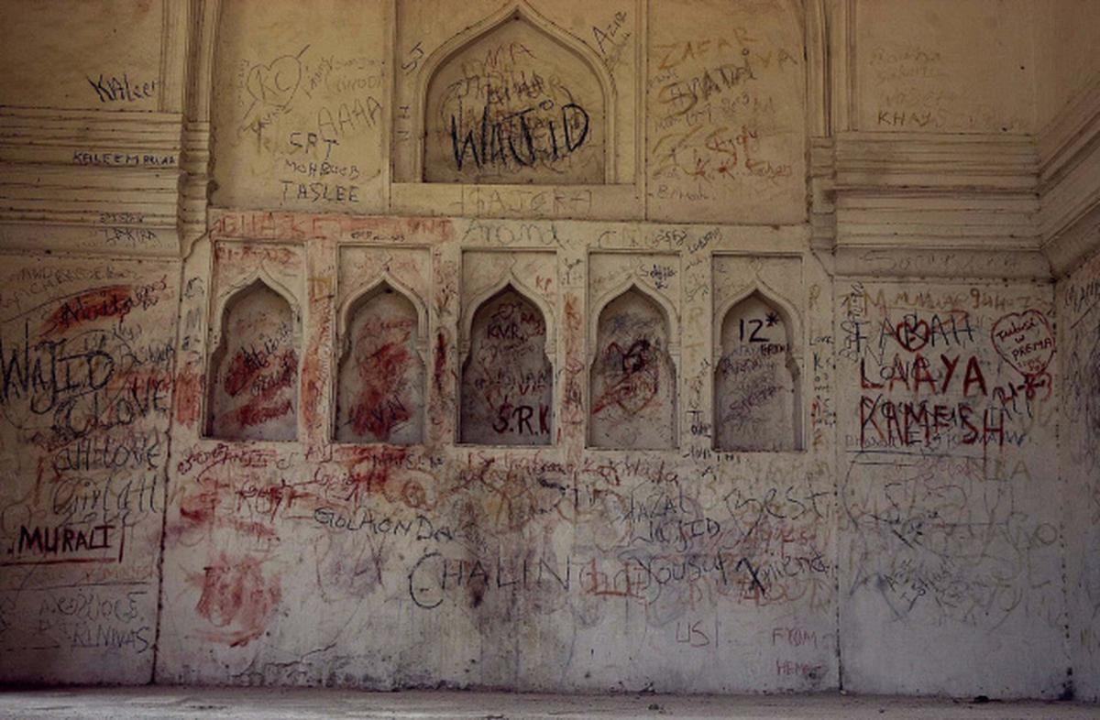
I was recently talking to a Dutch woman in her 60s and was genuinely disappointed.

Disappointed in how abysmal India has become for tourists.

Most of the tourists that we get are from Bangladesh.

24.5% of tourists are from the Indian diaspora itself.

7.26% of them are Medical tourists.

You either understand the culture to know what to expect, or you have to be here out of necessity.

Best case, you thought "connecting" to your roots would be nice, and maybe the illusion of a place brimming with spirituality made you come.

"I'm never coming here again- I travelled across 7 countries over the past 40 days, and it was only in Jaipur where I broke down".

The nationalistic training we've had over the recent years almost made me say "So go back to your own country" too

hai na- instant response humare paas?

She did go back. She'll never come. Is that really a win? Considering about 6-8% of the Country's GDP is powered through tourism?

We've focused way too much on the product that Indian tourism is-

We have the Taj Mahal, We have the Himalayas, We have a huge coastline, we have insane diversity. We have undiscovered gems and lots of "culture".

So far so good. Lots of pride taken, lots of fantastic points about why India is so great collected for our dinner table debates.

But any decent business person knows the product itself is not enough- the product experience makes or breaks the fact if you are going to retain clients/users.

We're doing much better on the domestic tourism front, but that is just circulating money within the country. We need more foreign exchange to come in, and that requires the experience to be pleasant and safe for people who bring it.

And we are abysmal at that.

In a nation that is focused on being more and more closed culturally, and has low tolerance for even its own linguistic and ethnic diversity, there is no way that any "outsider" will be seen as anything but a cash cow.

That is not a great feeling to have. That is how most people who visit with simply an "Idea of India" go back feeling.

It is an extractive system and It will keep getting worse as
- The income disparity rises
- Cultural and regional struggles increase
- "Indianess" becomes increasingly closed
- Tourist channels remain largely unregulated
- We focus only on "what we're offering" and not how they experience it.

It is okay if you charge folks more. But seriously, make it worth it!

BeSci and Context Arc. have a strong case when it comes to improving tourism here.

For instance, the tourist told me how "strange" it was when she saw people marking and engraving their names at the red-fort.

Even though it is a daily "fact" for me, one can't shy away from the fact that it needs improvement!

Apply the Broken Windows theory well enough, you have one problem solved.

Make graffiti and scribbling alleys nearby, make it a thing in itself - figure out the "how".

Let people have their Laila Majnu moments there.

Care enough. Do more.

